NAME – DEEPANSHU SHARMA
SAP ID – 590028556
BATCH NO – 19
TOPIC - CELEBRITY PROBLEM

The Celebrity Problem
1. Problem Statement
There are N people at a party. Among these N people, there may be one person who is a celebrity. A celebrity is a person who is known by everyone else at the party, but does not know anyone else at the party.
We are given an N by N matrix M, where M of i and j equal to 1 means person i knows person j. If M of i and j is 0, it means person i does not know person j.
The task is to find the celebrity among the N people using this matrix, or to say that no celebrity is present at the party. There can be at most one celebrity in the whole party.
2. Approach Used
Step 1: Take two pointers, one at the start and one at the end of the list of people.
Step 2: Compare the two people pointed by these two pointers. If the person at the start knows the person at the end, then the person at the start cannot be the celebrity, so move the start pointer forward.
Step 3: If the person at the start does not know the person at the end, then the person at the end cannot be the celebrity, so move the end pointer backward.
Step 4: Repeat step 2 and step 3 until both pointers meet at the same person. This person is the possible celebrity.
Step 5: Check this person against the full matrix. This person should not know anyone else, and everyone else should know this person. If this is true, this person is the celebrity. If not, there is no celebrity at the party.
3. C Program
The following program implements the celebrity problem using the two pointer method explained above. The program does not use any comments.

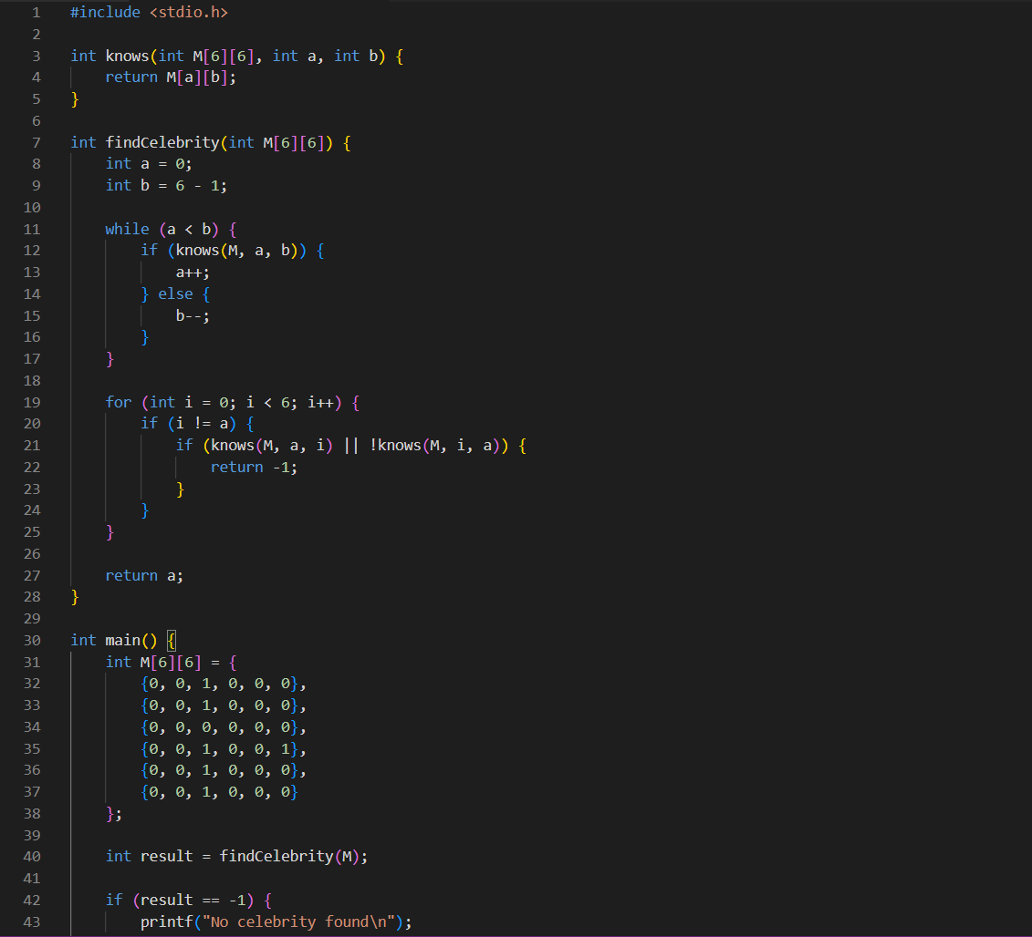
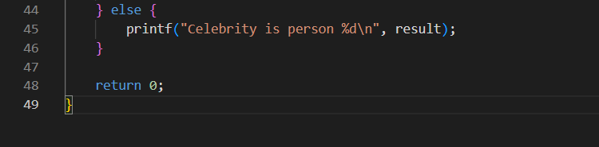
4. Output
The program was compiled and run on a party of six people. The output below shows that person 2 was found to be the celebrity for the given matrix.
